BANDARA H.G.T.D.

2022/E/048

GROUP CG04

SEMESTER 05

2025/06/27

**DATABASE MANAGEMENT STSTEMS**

**LAB RESCHEDULING MANAGEMENT SYSTEM DATABASE PROJECT**

**LAB RESCHEDULING MANAGEMENT SYSTEM DATABASE PROJECT**

**INTRODUCTION**

In academic institutions, laboratory sessions are critical components of technical education that require precise scheduling and coordination among multiple stakeholders. The Lab Rescheduling Management System addresses the challenges of traditional manual processes by providing a comprehensive database-driven solution that automates the entire rescheduling workflow. The Lab Rescheduling Management System leverages database technology to automate and streamline the process of requesting, approving, and tracking lab rescheduling, enhancing operational efficiency and communication among all stakeholders. This system facilitates seamless communication between students, subject coordinators, and lab instructors while maintaining detailed logs of all activities and ensuring optimal utilization of laboratory resources.

**PROBLEM STATEMENT**

The current manual approach to lab rescheduling creates numerous operational inefficiencies and communication gaps. Students face difficulties when they need to reschedule lab sessions due to conflicts or emergencies, often resulting in delayed approvals and missed notifications. Subject coordinators struggle to track multiple rescheduling requests, verify approval letters from faculty, and coordinate with lab instructors effectively. Lab instructors lack visibility into incoming rescheduling requests and have limited tools to manage lab availability and capacity. This fragmented process leads to scheduling conflicts, poor resource utilization, communication breakdowns, and inadequate tracking of lab usage patterns, ultimately affecting the quality of technical education.

**AIM**

The primary aim of this project is to design and implement a robust Lab Rescheduling Management System that streamlines the entire rescheduling process through automated workflows, real-time notifications, and comprehensive data management. The system seeks to enhance operational efficiency by providing role-based access control for different user types, maintaining detailed logs of all rescheduling activities, generating comprehensive reports on lab usage and scheduling patterns, and ensuring seamless communication between all stakeholders throughout the approval process.

**PROBLEM SOLUTION**

The Lab Rescheduling Management System provides a centralized digital platform that automates the complete rescheduling workflow from request submission to final approval. The Lab Rescheduling Management System offers a digital platform where students can submit rescheduling requests, subject coordinators can review and approve requests, and lab instructors can manage lab allocations. The system automatically notifies relevant users about the status of requests via email, maintains comprehensive logs of all activities, and generates detailed reports on lab usage and rescheduling history. This approach minimizes manual intervention, reduces errors, and ensures all stakeholders are promptly informed.

**KEY CHALLENGES**

* Designing a flexible database schema to accommodate various user roles and dynamic lab schedules
* Implementing a multi-step approval workflow with secure role-based access control
* Ensuring real-time synchronization and notification for all stakeholders
* Handling concurrent requests and avoiding scheduling conflicts
* Maintaining comprehensive logs and generating accurate usage and rescheduling reports.

The development of this system presented several significant technical and operational challenges. Creating a flexible database schema that accommodates multiple user roles while maintaining data integrity across concurrent transactions required careful normalization and constraint implementation. Designing a multi-step approval workflow with secure role-based authentication posed challenges in ensuring proper access controls and maintaining audit trails.

Implementing real-time notification systems that reliably deliver status updates to all relevant parties required integration with email services and careful error handling. Managing concurrent rescheduling requests while preventing scheduling conflicts demanded sophisticated conflict detection algorithms and transaction management. Ensuring data consistency across multiple tables while maintaining system performance during peak usage periods required optimization of database queries and indexing strategies.

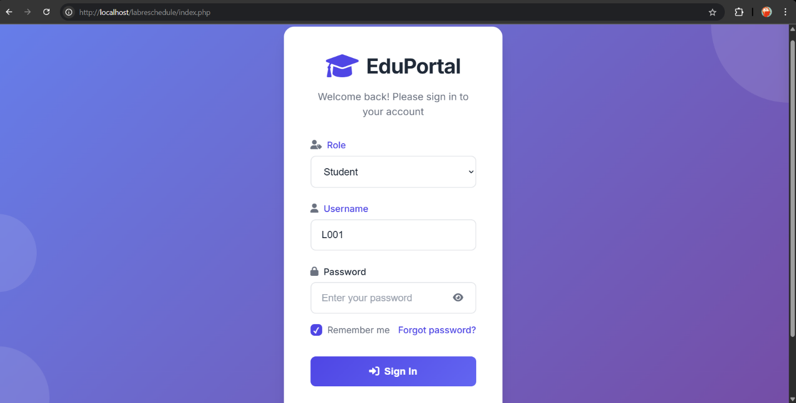**INTERFACES**

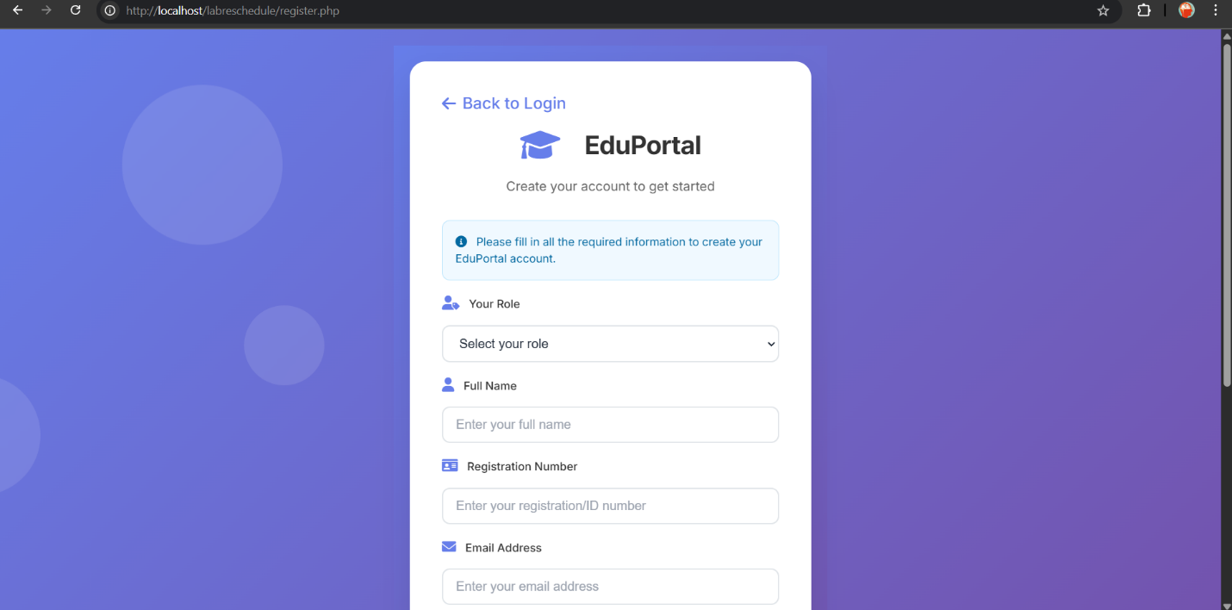**FIGURE 01: LOGIN PAGE**

**FIGURE 02: SIGN IN PAGE**

**FIGURE 03: STUDENT DASHBOARD PAGE**

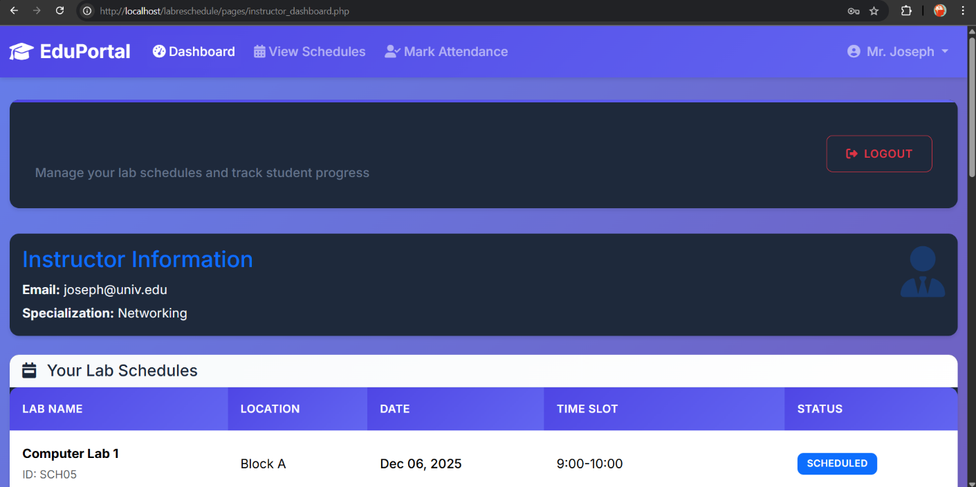**FIGURE 04: INSTRUCTOR DASHBOARD**

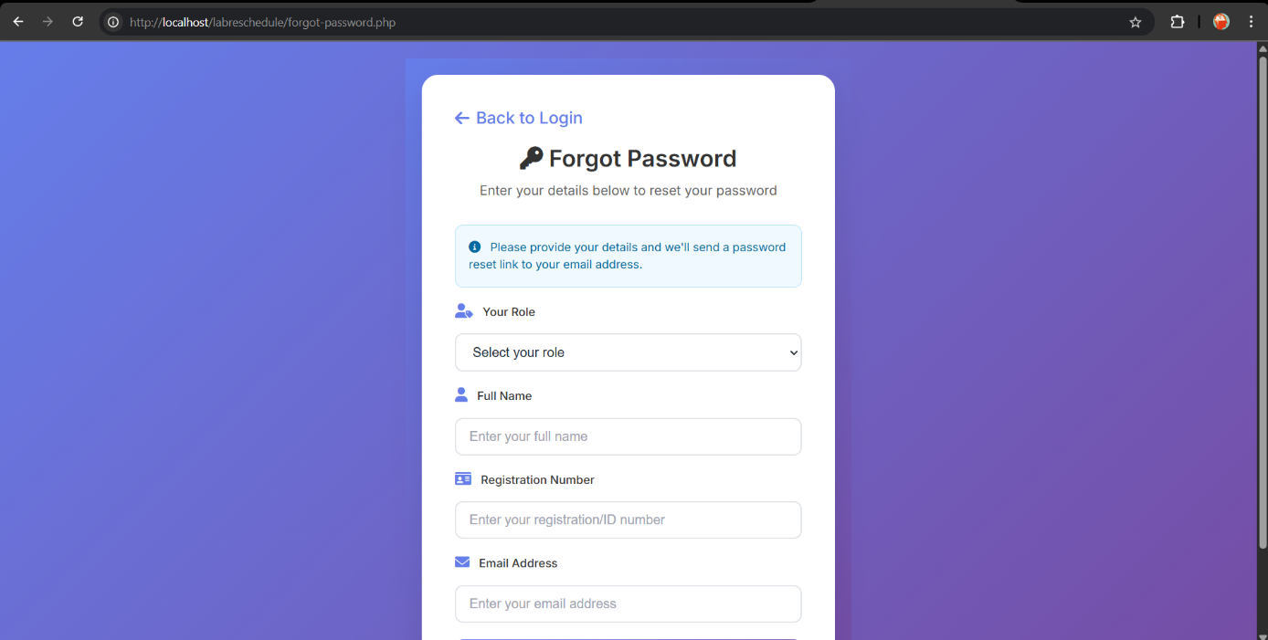**FIGURE 05: ATTENDANCE MARK PAGE**

**FIGURE 06: FORGRGET PASSWORD PAGE**

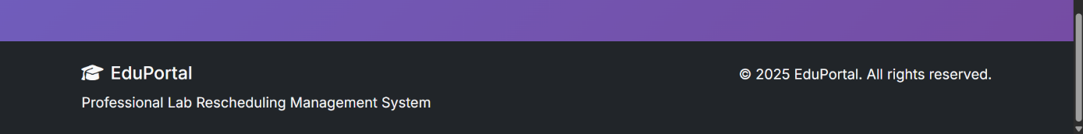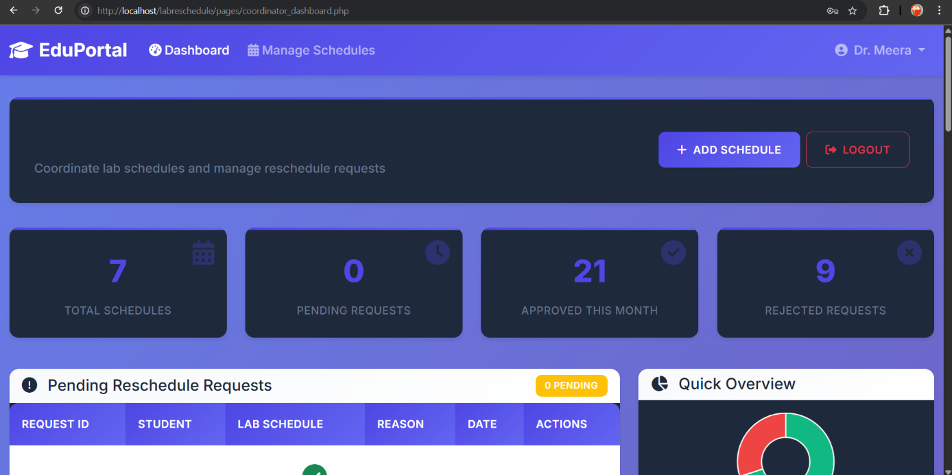**FIGURE 07: COORDINATOR DASHBOARD**

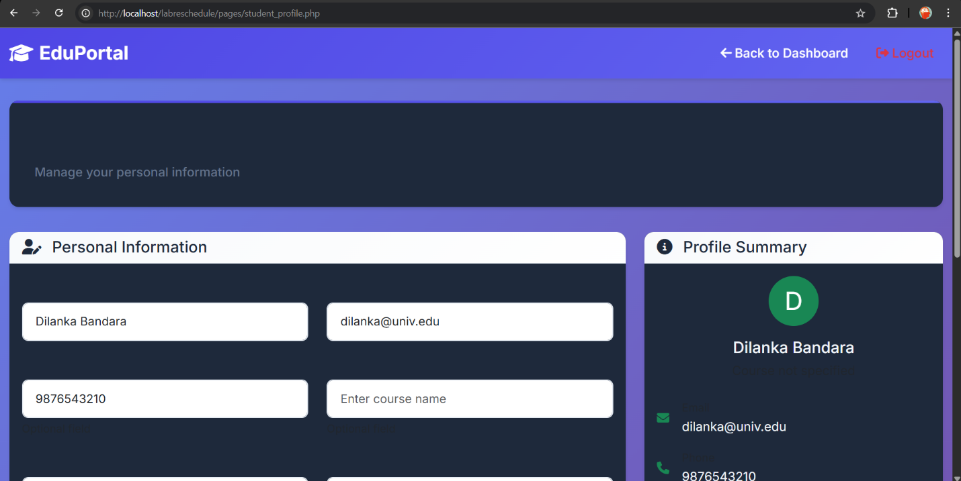

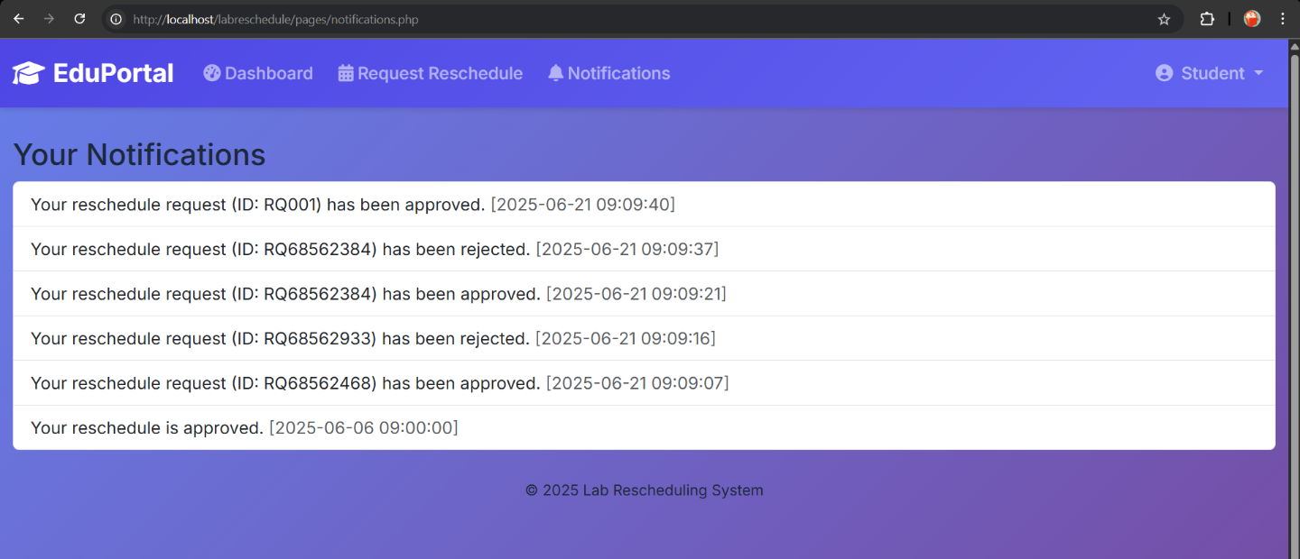**FIGURE 08: ATTENDANCE MARK PAGE**

**FIGURE 09: NOTIFICATION PAGE**

**FIGURE 10: SETTING PAGE** A screenshot of a computer

AI-generated content may be incorrect.A screenshot of a computer

AI-generated content may be incorrect.A screenshot of a computer

AI-generated content may be incorrect.

**FIGURE 11: INTERFACE TO ADD NEW LAB SCHEDULE**

**FIGURE 12: INTERFACE TO REQUEST LAB RECHEDULE**

**FUNCTIONS**

* Submit lab rescheduling requests with supporting documents
* Multi-level approval workflow (student → coordinator → instructor)
* Real-time email notifications for request status updates
* View and manage lab schedules and availability
* Track and log all rescheduling activities and approvals
* Generate reports on lab usage, rescheduling frequency, and user activity